

Children’s Care

Learning & Development Programme

Updated April 2021



**Contents**

|  |  |
| --- | --- |
| Setting the Scene in Middlesbrough | Page |
| **Welcome and Introduction from the Director and Principal Social Worker** | **3** |
| **The Offer Explained** | **4** |
| **Our Organisational Values and Practice Priorities** | **5 - 6** |
| **Children and Relationships First** | **7** |

|  |  |
| --- | --- |
| The Learning And Development Offer | Page |
| **The Induction** | **8 - 9** |
| **The Core Offer** | **10 - 12** |
| **The Development Offer** | **13** |
| **The Learning and Development Course Library** | **14** |
| **Early Help Multi Agency Offer** | **14** |
| **The ASYE Programme** | **15** |

|  |  |
| --- | --- |
| Engaging With Development | Page |
| **Closing The Learning Loop** | **16** |
| **The Voice of Children and Young People** | **16** |
| **Contact Details** | **16** |

**Introducing the Children’s Services Learning and Development Programme**

As an organisation, Middlesbrough Council are committed to the professional development of all of its staff.

In Children’s Care we have created our new Learning and Development Offer which encompasses a wide variety of training opportunities to ensure that employees are equipped with the skills and knowledge to meet the demands of their roles.  
  
The Offer itself has been carefully considered and aligns itself with the new Practice Model and Practice Standards contributing to services overall priority of “Children and Relationships First”.  
  
The Learning and Development offer caters for employees in all roles, at all levels. From the induction programme, right through to specific management training opportunities aimed at aspiring and established leaders with the service.  
  
As an organisation we promote a learning culture with the ambition of continually improving our practice and in turn, the outcomes for the children and families that we work with. We encourage employees to engage with the offer and in return promise to support our staff in their development. To ensure our offer meets your needs there are a variety of different delivery methods including; E-Learning, short educational videos, interactive face to face seminars, virtual training and hot topic sessions.   
  
Employees will also have access to Community Care Inform website. This includes a range of research, resources and toolkits to support you in your practice.

**We are committed to the continual professional development of our entire workforce. Whilst we appreciate certain service areas will have specific statutory standards they need to adhere to, this offer will compliment those and engagement is welcomed from all Children’s Care employees as well as Middlesbrough Foster Carers.**

**Engagement with this offer will help to ensure that as a service, we have the necessary knowledge and skills to meet the needs of children and families in Middlesbrough.**

|  |  |  |
| --- | --- | --- |
| **Sue Butcher Executive Director Children’s Services** | cid:2721614183869065864414601**Rachel Farnham Director Children’s Care** | **Siobhan Davies Principal Social Worker Children’s Care** |

The InductionAs an employee of Middlesbrough Council you are required to complete your induction within 6 months of your start date to meet your corporate responsibilities. If there are any courses in this section you have not completed already, you should ensure you do so as quickly as possible.

The ASYE Programme  
Middlesbrough Council provides a specifically tailored ASYE Learning and Development Programme delivered through our Centre for Practice Excellence.   
  
Newly Qualified Social Workers (NQSW) will be provided a 12 month curriculum of learning within which there will be a strong focus on the Knowledge and Skills Statements, Middlesbrough’s Practice Model and Practice Standards. The learning sessions include guest speakers from within the organisation, partner agencies and those with lived experience. There is a strong emphasis on reflective practice, learning through being curious and adapting to constructive feedback.   
  
The child’s journey, along with developing best practice for exploring and understanding the child’s world are integral parts of our ASYE curriculum.

The Core OfferOur Core Offer is tailored to the needs of Middlesbrough Children. It has been developed with a focus on both national and local learning and supports the delivery of the Strategic Improvement Plan, Practice Model and Practice Standards. The courses within this section are courses that you are expected to prioritise and complete over a 3-year period. If you are a Social Worker who needs to meet Social Work England Continued Professional Development Standards this learning can be used as evidence towards that.

The Developmental Offer  
Supporting your career progression is important to us.  
  
The Developmental Offer is comprised of a range of courses available to those who either want to further develop skills and experience to work in a more complex way or those looking at their future career development, such as aspiring managers.

Places are subject to availability depending on the needs of the service and/or employee. These learning opportunities are to be discussed and agreed between employees and managers in supervision / appraisal.

The Learning and Development Course LibraryWe recognise that every family is unique and therefore we have a wide range of training available to support your learning as and when the need arises. A large proportion of the offer is E-Learning which enables you to acess bite size training opportunities at a time that is right for you and the children and families you are working with. Engagment with these opportunities should be identified by both employee and manager in supervision and appraisal. Places may be subject to availability and courses will be comissioned in line with service needs. You can book via Middlesbrough Learns as a “Self-Service” process.

**Organisational Values & Practice Priorities**Our Values are at the heart of everything we do here at Middlesbrough Council. They are a critical element of our strategy to create a brighter future for Middlesbrough, and the foundation for how we operate, interact and make decisions.

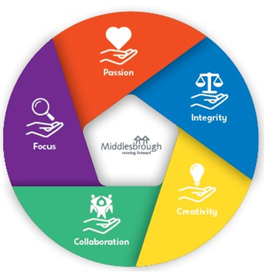From creative ideas, to working collaboratively within the organisation and with external agencies, to being passionate about doing things better - we can make a real difference to the people and place we serve.

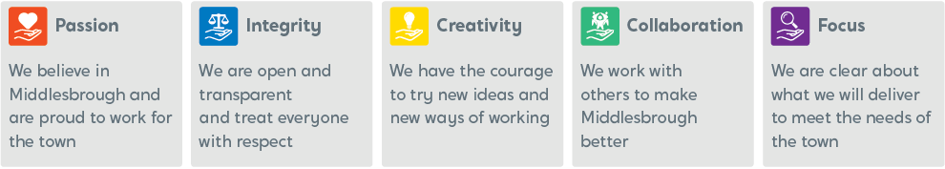

Our plans for Middlesbrough and its people are creative and ambitious and we all have an important part to play in delivering these plans to achieve the Mayor’s Vision.

**Tony Parkinson  
Chief Executive – Middlesbrough Council**

**P’s & Q**

To complement our Organisational Values, in Children’s Services we have created our P’s and Q.

Our P’s and Q underpin everything that our improvement journey entails along with the priorities for the children and families that we work with.

**Quality**

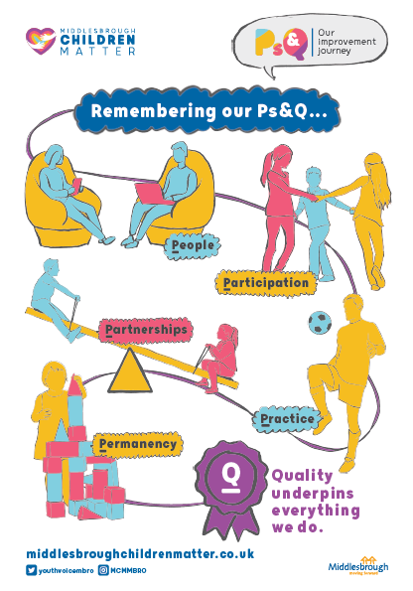**Priorities for our Children**

Children receive the **right support at the right time**

Children’s needs are understood and met through **good quality assessment** and review

Children are supported to **remain within the family,** where this is not possible permanence planning is achieved in the child’s timescales

Children are at the **centre**

Children benefit from **effective Supervision**, management oversight and decision making

We have strong **partnerships** that lead to better outcomes for children and young people

**Middlesbrough Practice Model and Standards**

Children and Relationships First  
In Middlesbrough Children & young people are at the centre of everything we do! We prioritise Children & Relationships first.

When using the model, we will:  
  
1. Focus on strengths, balancing risks, safety and capacity to change  
2. Engage the whole family, not leaving anyone out!  
3. Build on relationships, working “with” rather than doing “to” families.

In addition to our Practice Model, Middlesbrough’s Practice Standards have been developed by employees for Middlesbrough children and their families. They provide a consistent understanding of what good practice looks like. The Training and Development offer is designed to support you to deliver good practice based on these standards and our practice model.

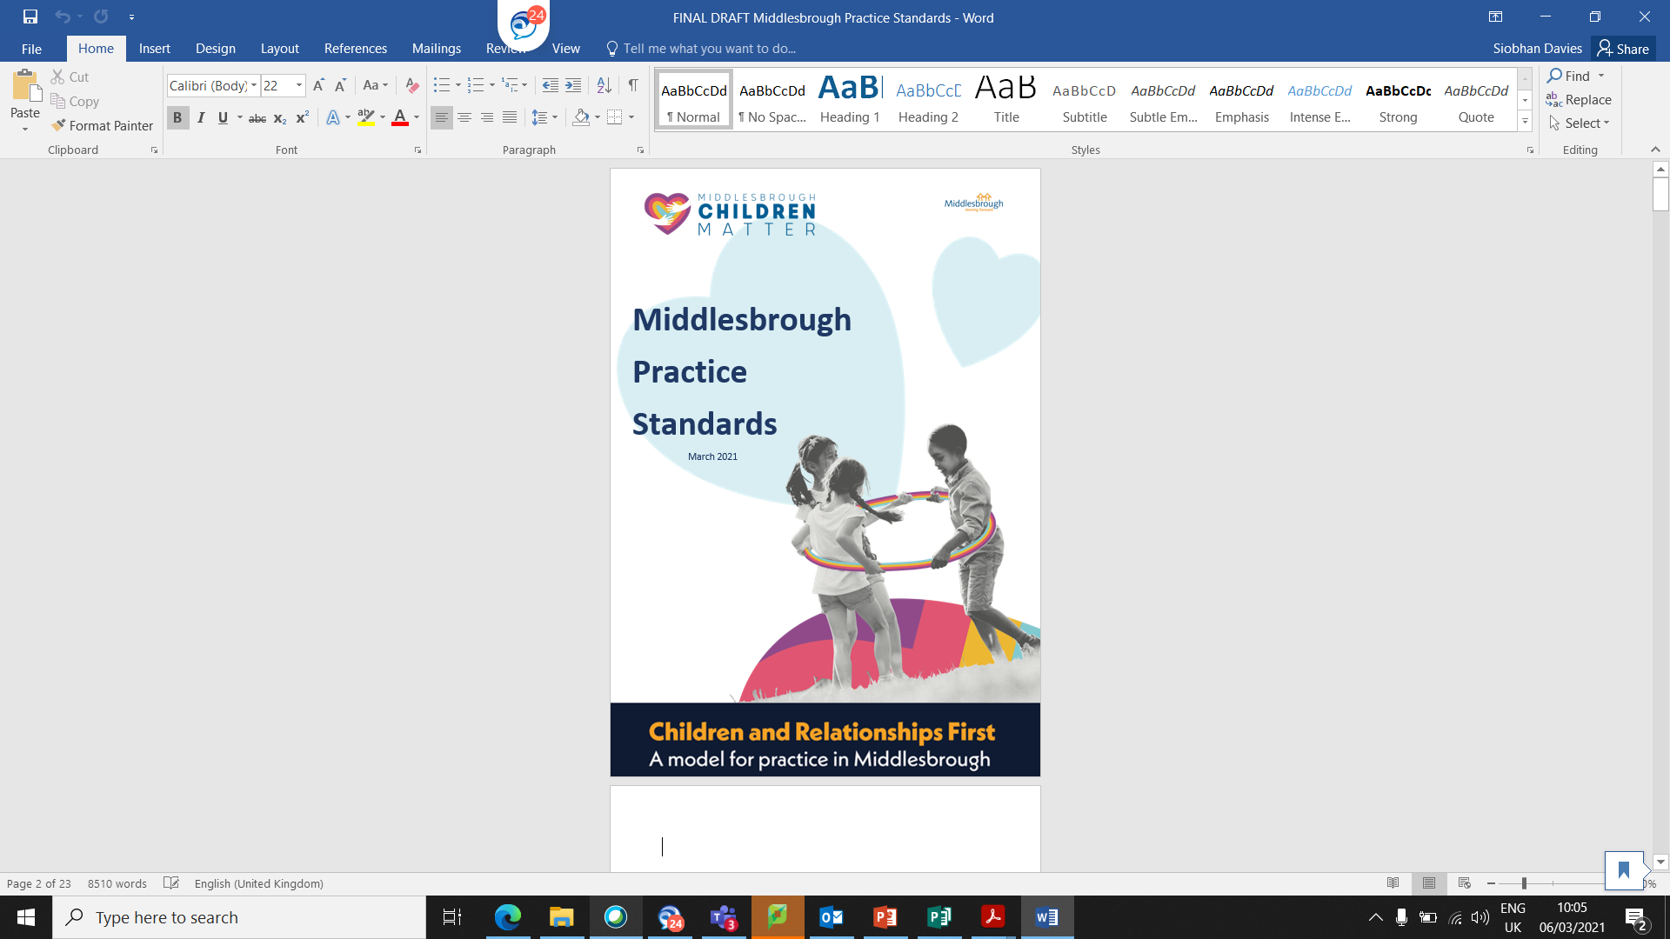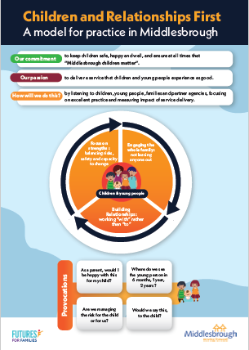

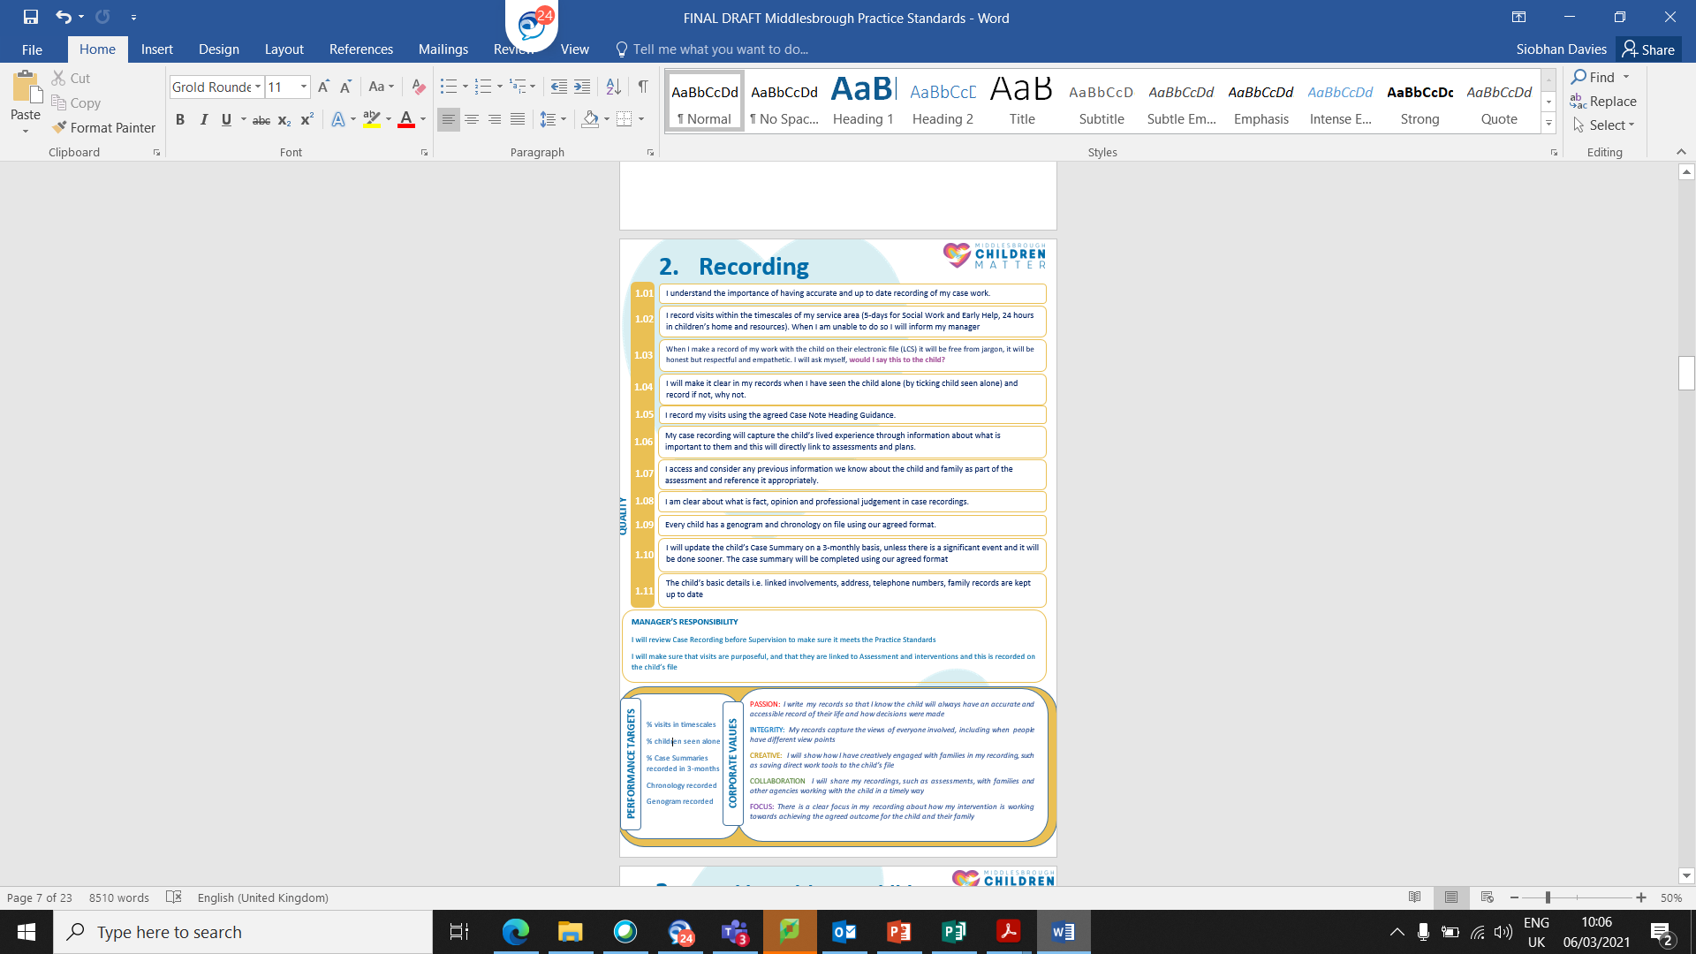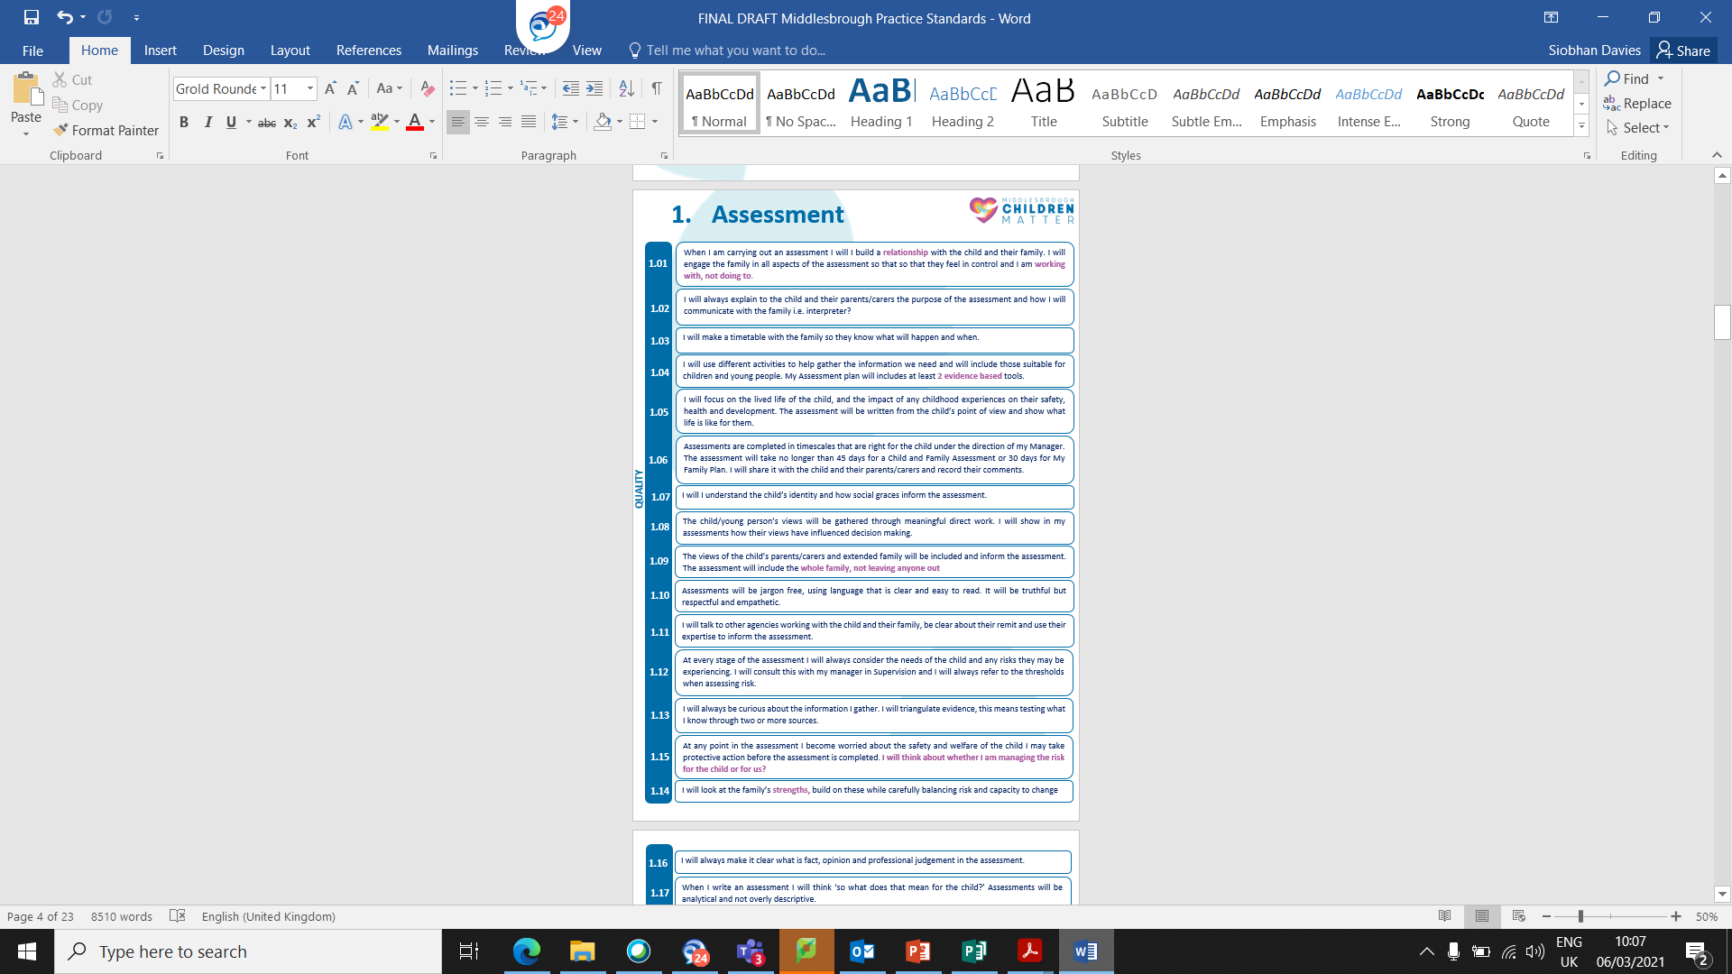

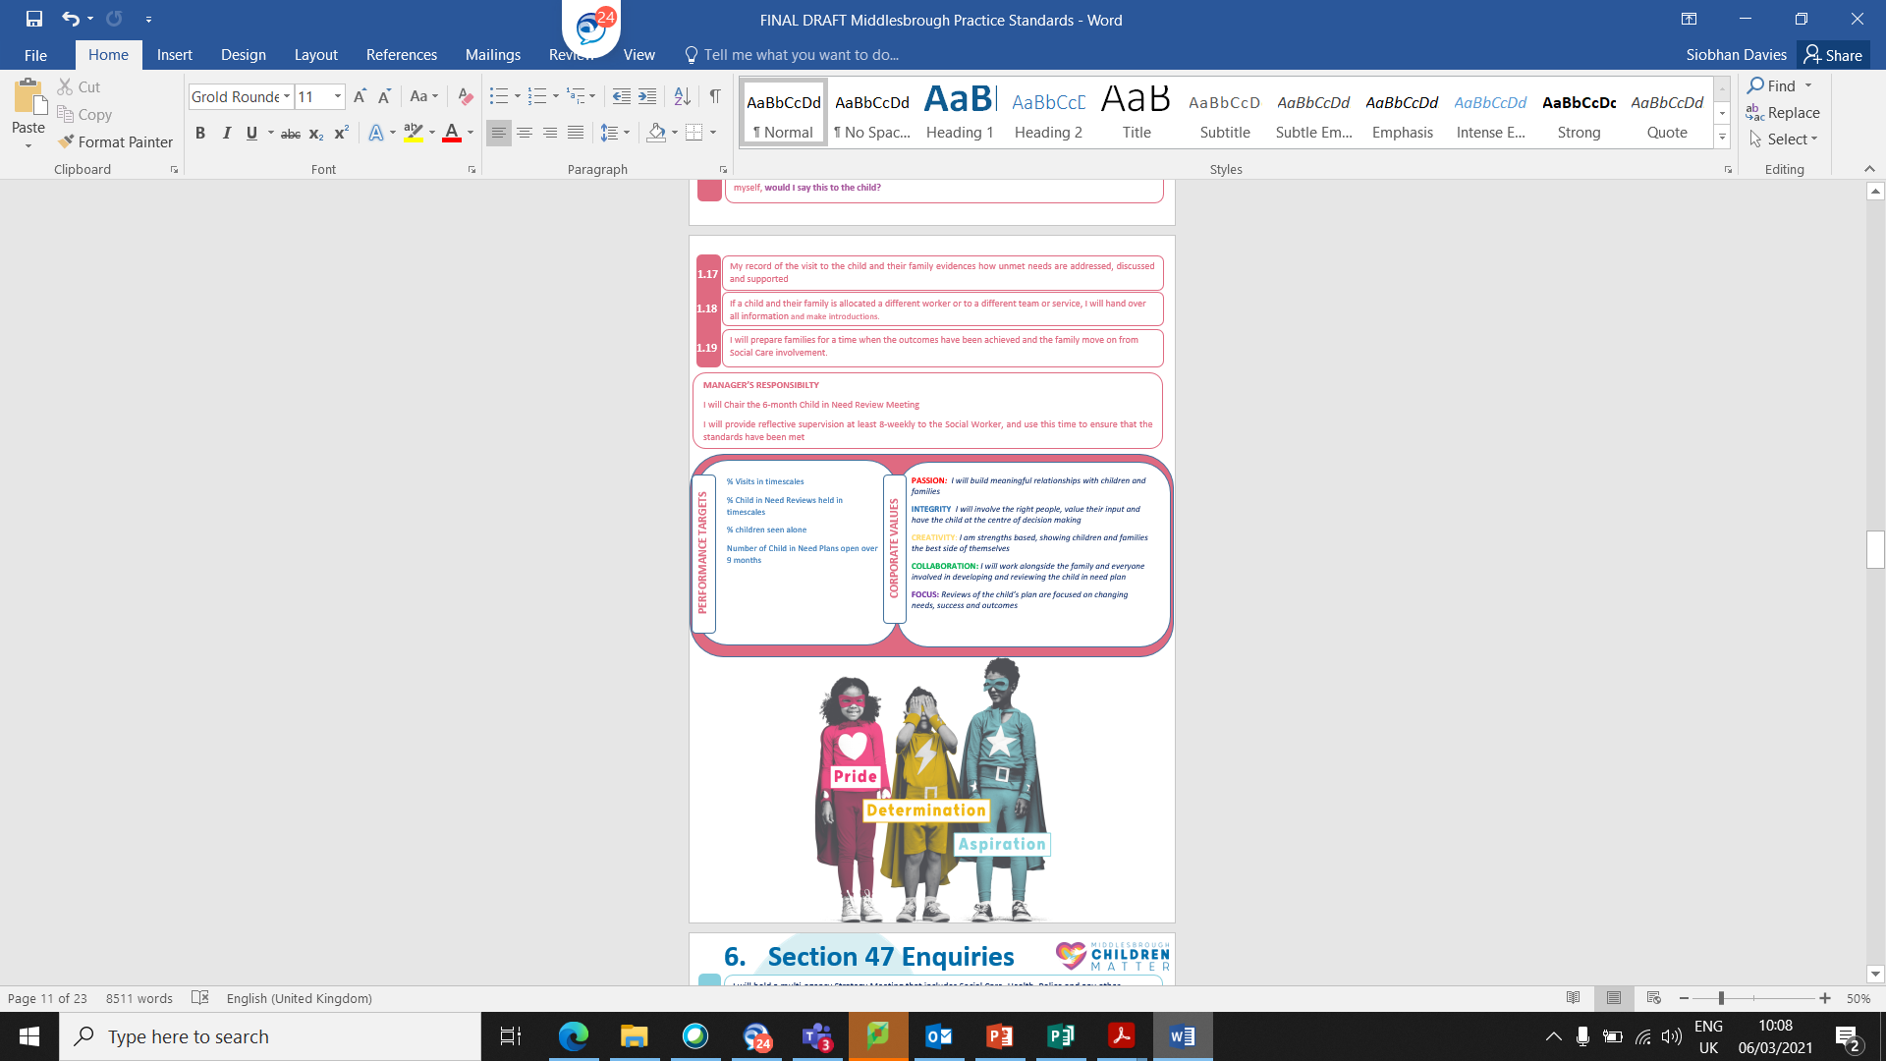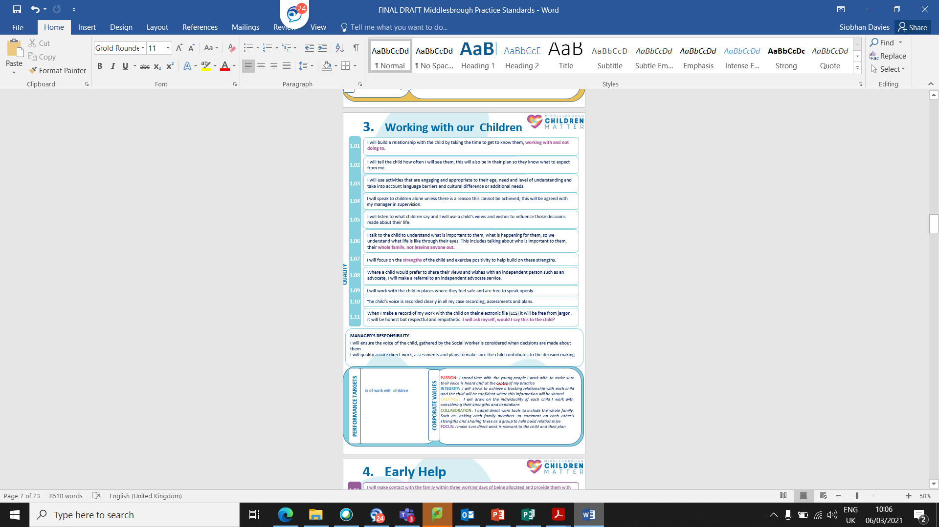

|  |  |
| --- | --- |
| **Practice Model Document** | **Practice Standards Document** |
|  |  |

**The Training and Development Offer**The Induction  
As part of your induction to Middlesbrough Council, you will be required to undertake a range of mandatory E Learning as a corporate requirement. This includes, but is not limited to

* GDPR Training
* PREVENT Awareness and PREVENT Referrals
* Mental Health and Wellbeing Awareness

In addition to these corporate requirements, Children’ Services employees are also asked to complete the following service specific training as mandatory requirement.

Corporate Induction materials and E Learning can be found here:

* [Induction Materials (Induction Tab)](https://intranet.middlesbrough.gov.uk/recruiting-talent-0)
* [Corporate Induction](https://tld.middlesbrough.gov.uk/totara/program/view.php?id=13)

In addition to these corporate responsibilities, Children’s Care employees are also required to undertake the following within their 4 week induction period.

|  |  |  |
| --- | --- | --- |
| **Children’s Services – Induction** | | |
| LCS/EHM Training | These courses are aimed aimed at new starters in within Children's Services and provide knoweldge of the relevevant recording sytem. | E Learning  Or Seminar |
| Practice Standards | This short video provides an overview in to the service area’s Practice Standards | Video |
| CC Inform Introduction and Registration | This area will give you a brief overview of our online learning resource CCInform, you will be able to find information on:   * What is CC Inform? * How do I register? * What are the benefits? | Information Page |
| Tri.x – Children’s Services Procedure Manual | This training will help you to understand how to navigate and access Middlesbrough’s policies and new system.  In addition it will:   * Provide skills for you to champion for the Tri.x system within your team. * Familiarise you with the online procedures manual, how to access it and use it, saving to Favourites and adding a desktop icon. * Give a demonstration of how to use the full functionality of Tri.x | Seminar |
| Threshold Training | This short video will provide you with information on how:   * To underline principles of intervention in family life * To consider the meaning of ‘thresholds’ and the relevance for our work and the families we work with. * To identify the range of influences and biases that can contribute to our understanding of threshold decisions. * To link the child’s specific needs to decisions that can be made and how that decision contributes to meeting the need. * To become familiar with both the Continuum of Need and the document ‘Significant Harm and Significant Impairment of Health and Development: A Guide for Decision Makers.’ * To apply the continuum of need and decision making guide to a family situation and consider the child and family perspective on decision making. | Video |
| SEND E Learning | Since Middlesbrough’s Local Area Inspection of special educational needs and disability (SEND) in March 2017, colleagues across education, health and care have considered the information, advice and training opportunities available for professionals who may at some point, work with children and young people with SEND.  As part of this work, an e-learning tool has been developed with the aim of providing a basic introduction to SEND for professionals. It is to provide an entry level insight into many of the procedures, types of intervention and the support available within Middlesbrough to help identify, assess, support and review the needs of children and young people with SEND in Middlesbrough. | E Learning |

The Centre for Practice Excellence Commitment  
To ensure that both new starters and current employees feel supported in their learning journey, The Centre for Practice Excellence commits to:

* New Starters   
  The Centre for Practice Excellence will contact all new starters and offer the opportunity to talk through the Learning and Development Offer, including any personal areas of development and career development aspirations.
* Current Employees  
  In addition to the above, The Centre for Practice Excellence will also be available for “Career Consultations” for those wishing to discuss progression, development and further career aspirations.  
    
  Current employees looking to arrange a “Career Consultation” should contact: [C4PE@middlesbrough.gov.uk](mailto:C4PE@middlesbrough.gov.uk)



Core Training in Children’s Care  
Our Core training is a minimum expectation of all employees within the Children’s Care Service Area and is comprised of a range of training to help staff meet the needs of their role.

This package of training has been carefully considered in line with the priorities deriving from The Council Plan, Children’s Services Improvement Plan and the Children’s Services Workforce Development Strategy.

As part of the wider Training and Development Offer, this package of core training will support employees to:

* Keep children safe, happy and well
* Deliver a service that children and young people experience as good

|  |  |  |
| --- | --- | --- |
| **Children’s Services – Core Training** | | |
| Analytical Assessments | This course demonstrates how to prepare a good quality, analytical assessment that understands what life is like for the child.  It is underpinned by Middlesbrough Practice Model and Practice Standards and will cover the importance of preparing yourself and the family for assessment.  Key skills focussed on within the training will be; the difference between fact, opinion and professional judgement, using evidence based tools to gather information and make decisions and the way in which the assessment informs the plan for the child and their family.  **Analytical Assessments Training is currently delivered through our “Assesment Pods” as part of the wider Strengthening Practice Programme in Middlesbrough.**  **Should a need for additional sessions be identified, seminars will be provided in house by our Practice Lead’s.** | Seminar |
| SMART Planning | This course will teach you how to create SMART plans that set out how we will achieve the agreed goals for the child and their family.  There will be a specific focus in the session on Safety Planning.  **SMART Planning is currently delivered as part of the wider Strengthening Practice Programme in Middlesbrough.**  **Should a need for additional sessions be identified, seminars will be provided in house by our Practice Lead’s.** | Seminar |
| Communicating With Children | This course is underpinned by Middlesbrough Practice Standard, Working with Childen. It will encourage creative ways of engaging and communicating with children and young people.  It offers a range of helpful tools that can be used to hear from the child, depending on the focus of the conversation. You will have opportunity to practice some tools within a safe and confidential space.  It will cover the importance of meaningfully gathering the views of the child to inform assessment and decision making, and being clear about how you record on the child’s file. | Seminar |
| Section 47, enquiry | This course is underpinned by Middlesbrough Practice Standard ‘Section 47 enquiries’. It will support your knowledge and understanding of the process, legaslative framework and demonstrate what good looks like for Middlesbrough children. | Seminar |
| Child Sexual Exploitation | This course is designed to increase awareness of child sexual exploitation and provide staff with a greater understanding of the issues and processes so that children and young people can be safeguarded. | E Learning |
| County Lines | This E Learning module will explore the ways children, young people and vulnerable adults are exploited by criminal activity and give you mechanisms to safeguard and take action when someone is at risk. | E Learning |
| Domestic Abuse | This course is designed to increase understanding and awareness of domestic abuse as well as its impact on both parenting capacity and children’s health, development and wellbeing. | E Learning |
| Court Skills & Pre Proceedings | This training is delivered over the course of two workshops and will focus on:   1. The legal and policy context to care proceedings and pre-proceedings. 2. Effective Pre-Proceedings 3. Effective Care Proceedings   The content of sessions will be a mixture of relevant legislative detail, policy and process. | Seminar |
| Graded Care Profile | This course aims to give participants a clear understanding of theory and research evidence that informs and underpins the Graded Care Profile.  In addition, it will:   * Ensure participants understand the properties and evidence based construct of the tool. * Ensure participants understand how the tool captures key aspects of physical and emotional care and how it can contribute to assessments of child neglect. * On completion of the training, participants will be equipped with ability and understanding of how to use the tool in practice | Seminar |
| Child Safeguarding Practice Reviews | This training aims to share key learning points from local Child Safeguarding Practice Reviews (formally serious case reviews) and enable the embedding of these key findings in practice. | Seminar |
| Life Story Work | Life Story Work is an important way of helping a child integrate their past into the present, helping them move foward into their future successfully.  This training will help you consider and create a secure base for a child to help them explore their past, present and future.  In addition, it will help you to use Middlesbrough’s Life Story Toolkit to plan, carry out, record and present Life Story Work with children in our care. |  |
| Neglect | This course is designed to raise the profile of neglect as a form of maltreatment, and to improve professional responses to children who are being neglected. | E Learning |
| Permanency | A specific programme of Permanency Training to be developed and delivered in the coming months. |  |
| Substance Misuse (Drug and Alcohol Awareness) | This module aims to raise your awareness of drugs and alcohol looking at recommended guidelines for alcohol consumption, useful tips for cutting back as well as the more common drug types and their side effects and symptoms.  We will also provide sources of support for individuals and employers with information on the early warning signs that someone is developing a substance misuse problem and how to deal with it | E Learning |
| Chronologies | Frontline to provide a training offer with the priority of chronologies. |  |

The Developmental Offer  
The Developmental Offer encompasses both areas relating to specific areas of social work / early help practice and a range comprehensive leadership and management training opportunities.

Whilst these courses are not mandatory, we encourage staff to engage with the development offer in an effort to continually improve practice standards and outcomes for children and families within Middlesbrough.

The courses within this section are comissioned and provided by both Middlesbrough Council and the South Tees Safeguarding Safeguarding Children Partnership.

|  |
| --- |
| **Blue** – Specific Developmental Opportunities for Social Workers |
| **Orange** – Specific Requirements of All Middlesbrough Managers (Aspiring managers require authorisation from their manager before registering on this training) |

|  |  |
| --- | --- |
| **Children’s Services – Development Offer** | |
| Achieving Best Evidence | Seminar |
| Age Assessments | Seminar |
| AIM3 | Seminar |
| Practice Educator Stage 1 | Seminar |
| Practice Educator Stage 2 | Seminar |
| **Middlesbrough Managers** | |
| HR/ OD Update | E Learning |
| Absence Management | Seminar |
| Chairing Safeguarding Meetings | E Learning |
| Corporate Procurement | E Learning |
| Decision Making Awareness | E learning |
| ILM | Contact OD |
| Insights Discovery in Leadership | E learning |
| LGSCO Effective Complaint Handling in Children's Social Care (CS Staff Only) | Seminar |
| Managing Capability and Disciplinary | Seminar |
| Project Management | E Learning |
| Recruitment & Selection | E Learning |
| Supervision Skills | Seminar |
| Leadership & Management – Strengthening Practice (CS Staff Only) | Seminar |

|  |  |
| --- | --- |
|  | |
| The Offer: | [South Tees Safeguarding Children Partnership – Training Offer](https://stscp.co.uk/training/) |
| E Learning Packages: |  |

The Learning and Development Course Library  
The Course Library is a range of E Learning training available to all staff within Childrens Care.

To continue to develop and improve the service in which we work – we would engourage all employees to engage with this offer where possible.

Please follow the below Middlesbrough Learns link to access the full list of available E Learning.



Multi Agency Training Offer  
In addition to the courses we deliver internally, we also have an ongoing commitment to working collaboratively with local partners to deliver a range of mutually benificial training, including:

* Threshold Training
* My Family Plan Training
* Middlesbrough Practice Standards Training
* SEND E Learning

Moving forward, we will continue to develop and broaden this offer which will feed in to the wider Partnership Training Offer.

For further information on this please contact: [C4PE@middlesbrough.gov.uk](mailto:C4PE@middlesbrough.gov.uk)

The ASYE Programme  
Learning and Development for Newly Qualified Social Workers

The ASYE Programme has been carefully designed by our Professional Development and ASYE Managers to provide a tailored approach to learning for those new to the profession.

The programme is made up of 11 key modules to help promote learning and development within practice and has been carfully mapped to the post-qualifying standards: knowledge and skills statements for child and family practitioners.

|  |  |  |  |
| --- | --- | --- | --- |
| **Children’s Services – The ASYE Programme** | | | |
|  |  | The ASYE Induction |  |
| Module 1 |  | Self Care, Time Management, Reflective Supervision |  |
| Module 2 | KSS 1 | The relationships and effective direct work |  |
| Module 3 | KSS 2 | Communication |  |
| Module 4 | KSS 3 | Child Development |  |
| Module 5 | KSS 4 | Adult mental ill health, substance misuse, domestic abuse, physical ill health and disability |  |
| Module 6 | KSS 5 | Abuse & neglect of children |  |
| Module 7 | KSS 6 | Child & family assessment |  |
| Module 8 | KSS 7 | Analysis, decision-making, planning and review |  |
| Module 9 | KSS 8 | The law and the family and youth justice systems |  |
| Module 10 | KSS 9 | The role of supervision |  |
| Module 11 | KSS 10 | Organisational Context |  |

**Engaging with Development**Middlesbrough Council’s Children’s Services directorate prioritise the development of their staff to ensure all children and families receive the service they deserve. To ensure that the offer meets the demands of our workforce we continually seek feedback from all involved in the learning and development journey.

## The Voice of Children and Young People

At the heart of our Improvement Plan is our ambition to strengthen the influence and impact of the voice of children, young people and families. This means their voice will increasingly inform the design and delivery of services, and the way that they experience care and support.

Closing the Learning Loop  
Middlesbrough Council strives to provide a wealth of learning opportunities for its employees and we are constantly looking to develop and improve our offer. To help us do this, we expect all employees undertaking training to actively engage with the feedback process.  
  
With your feedback, as well as key information from providers, partners, performance data and audit outcomes, we will continually develop our offer to meet the needs of employees allowing you to deliver the best possible service for the children and families of Middlesbrough.

Please get in touch…  
For further information in relation to the Learning and Development offer, or for specific training related queries, please contact:

|  |  |  |  |
| --- | --- | --- | --- |
| **Name** | **Role** | **Email** | **Telephone** |
| Siobhan Davies | Principal Social Worker | Siobhan_davies@middlesbrough.gov.uk | 01642 513639 |
| Tom Crown | OD Business Partner | Thomas_crown@middlesbrough.gov.uk | 01642 729445 |
| Ella Seaton | OD Admin Officer | Ella_seaton@middlesbrough.gov.uk | 01642 727408 |
| [**Workforcedevelopment@middlesbrough.gov.uk**](mailto:Workforcedevelopment@middlesbrough.gov.uk)  [**C4PE@middlesbrough.gov.uk**](mailto:C4PE@middlesbrough.gov.uk) | | | |

